Woolcock Institute of Medical Research
Letter Cancellation Task
Technical Specifications for Research Tools

11/5/2018

Letter Cancellation Task (LCT)

The LCT predominantly evaluates attention, concentration and visuospatial scanning ability or visuospatial neglect, as well as measuring accuracy of selective attention

A large field of letters is displayed on the computer screen, including a target CAPITAL LETTERS, double spaces, or a mixture of both i.e. the dual task (First Condition).

Participants scanned this field, and are asked to mark as many capital letters displayed on the computer screen in 60 seconds using the mouse (this is performed twice – trials 0 & 1); then mark as many double spaces (trials 2 & 3), then as many capital letters and double spaces (trials 4 & 5).

On the final screen (trial 6) a combination capital letters and double spaces were displayed and participants were asked to complete the test in their own time (Second condition). This condition is performed once.

Variables evaluated are the mean number (average performance on trials 0-5) of:

- Correctly marked targets (“average hits”)
- Missed targets (“average omissions”) and;
- Non-targets incorrectly marked (“average commissions”).

Variables assessed during the final trial (trial 6) are (do not average these scores into the total for the first condition):

- Final hits
- Finals omissions
- Final commissions and;
- Final trial duration (seconds).

CONDITION | TARGETS | RAW DATA |  | SUMMARY VARIABLES
FIRST CONDITION | CAPITAL LETTERS | Durations_0 | Durations_1 | Variable name:  Average Hits  Variable Descriptor:  Correctly marked targets  Variable Code:  average of Hits_0 Hits_1, Hits_2, Hits_3, Hits_4, Hits_5  Variable name:  Average omissions  Variable Descriptor:  Missed targets  Variable Code:  average of Omissions_0, Omissions_1, Omissions_2, Omissions_3, Omissions_4, Omissions_5  Variable name:  Average commissions  Variable Descriptor:  Non-targets incorrectly marked  Variable Code:  average of Commissions_0, Commissions_1, Commissions_2, Commissions_3, Commissions_4, Commissions_5
FIRST CONDITION | CAPITAL LETTERS | Hits_0 | Hits_1
FIRST CONDITION | CAPITAL LETTERS | Omissions_0 | Omissions_1
FIRST CONDITION | CAPITAL LETTERS | Commissions_0 | Commissions_1
FIRST CONDITION | DOUBLE SPACES | Durations_2 | Durations_3
FIRST CONDITION | DOUBLE SPACES | Hits_2 | Hits_3
FIRST CONDITION | DOUBLE SPACES | Omissions_2 | Omissions_3
FIRST CONDITION | DOUBLE SPACES | Commissions_2 | Commissions_3
FIRST CONDITION | DUAL TASK | Durations_4 | Durations_5
FIRST CONDITION | DUAL TASK | Hits_4 | Hits_5
FIRST CONDITION | DUAL TASK | Omissions_4 | Omissions_5
FIRST CONDITION | DUAL TASK | Commissions_4 | Commissions_5

CONDITION | TARGETS | RAW DATA | SUMMARY VARIABLES
SECOND CONDITION | PROCESSING SPEED TASK (DUAL TAKS) | Durations_6 | Variable name:  Final hits  Variable Descriptor:  Correctly marked targets  Variable Code:  Hits_6  Variable name:  Final omissions  Variable Descriptor:  Missed targets  Variable Code:  Omissions_6  Variable name:  Final commissions  Variable Descriptor:  Non-targets incorrectly marked  Variable Code:  Commissions_6  Variable name:  Final trial duration  Variable Descriptor:  Total time taken to complete page  Variable Code:  Duration_6
SECOND CONDITION | PROCESSING SPEED TASK (DUAL TAKS) | Hits_6
SECOND CONDITION | PROCESSING SPEED TASK (DUAL TAKS) | Omissions_6
SECOND CONDITION | PROCESSING SPEED TASK (DUAL TAKS) | Commissions_6

Letter Cancellation Task - Participant Instructions (to be displayed on own page prior to each trial)

Capital Letters Condition
This task is called a cancellation task.
Look for the CAPITAL LETTERS on each line.
Mark each CAPITAL LETTER with the left button on the mouse
Go from left to right working as quickly as you can
If you make a mistake you can re-click on the letter to remove the cross.

Spaces Condition
This time - look for the D O U B L E S P A C E S
Mark the letter before AND after the double space with the left button on the mouse.
Go from left to right working as quickly as you can.
Try not to miss any.
If you make a mistake you can re-click on the letter to remove the cross.

Dual Condition
This time you have both tasks to do at once
Mark the CAPITAL LETTERS and
the letters before and after the D O U B L E S P A C E S with the left button on the mouse
Go from left to right, one after the other working as quickly as you can.
Try not to miss any.
If you make a mistake you can re-click on the letter to remove the cross.

Processing Speed Condition
In this final task -
Mark both the CAPITAL LETTERS and the letter before and after the
D O U B L E S P A C E S with the left button on the mouse
This time complete the entire page as quickly and accurately as possible.
Go from left to right as quickly as you can without missing any.
If you make a mistake you can re-click on the letter to remove the cross.
When you finish click 'Stop'

In summary:

There are 36 letters per line, ten (10) of which are capital letters; there are four (4) double spaces in each line.

Score the first and second conditions separately.

The First condition:

- Capital Letters task: testtimelimit=60000, duration/pages (milliseconds)
(Performed twice)

- Double Spaces task: testtimelimit=60000, duration/pages (milliseconds)
(Performed twice)

- Dual task: testtimelimit=60000, duration/pages in (milliseconds)
(Performed twice)

The Second condition:

- Processing speed task: Participant is timed until page is complete and he/she/they clicks “stop”
(Performed once)

Each of the First Condition tasks are repeated. The Second Condition is completed only once.

Page 1: Capital Letters Instructions
Page 2: Capital Letters Web Page view
Page 3: Capital Letters Instructions
Page 4: Capital Letters Web Page view
Page 5: Double Spaces Instructions
Page 6: Double Spaces Web Page view
Page 7: Double Spaces Instructions
Page 8: Double Spaces Web Page view
Page 9: Dual Conditions Instructions
Page 10: Dual Conditions Web Page view
Page 11: Dual Conditions Instructions
Page 12: Dual Conditions Web Page view
Page 13: Processing Speed Condition

For example:

Page 1 (Instruction)

Capital Letters Condition
This task is called a cancellation task.
Look for the CAPITAL LETTERS on each line.
Mark each CAPITAL LETTER with the left button on the mouse
Go from left to right working as quickly as you can
If you make a mistake you can re-click on the letter to remove the cross.

Page 2 (Capital Letters Web Page view)
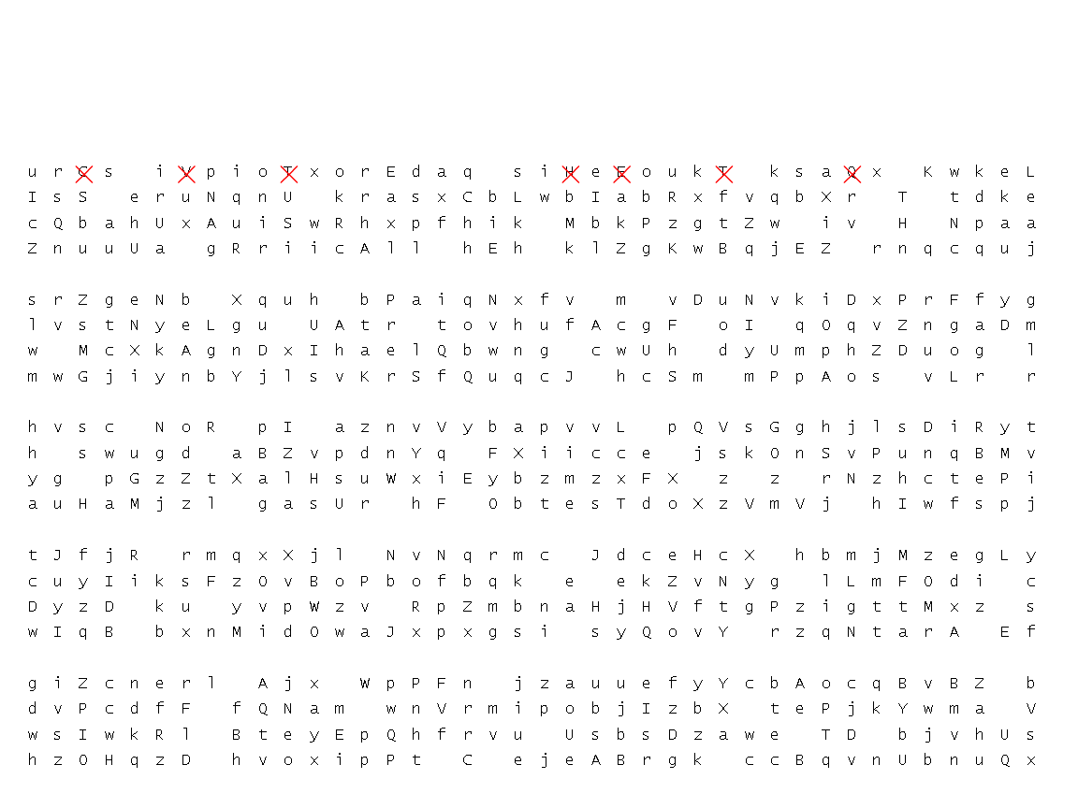

Repeat

Background - Neurocognitive correlates for variables:

Hit Rate (first condition):
This score represents the participants’ psychomotor processing ability (Focus & Execute measure), ability to engage in a directed attention task, and ability to use and sustain fine motor coordination. It is the primary measure of interest in this test.

Omissions (first condition):
This score represents the participant’s ability to direct attention to detail and to sustain that focus over time. It is a good indicator of disorders or states of inattention.

Commissions (first condition):
This score represents the participant’s ability to inhibit inappropriate responses. It is a good indicator of Impulsivity often found in disorders or states of inattention.

Error pattern (first condition):
Noting the right vs. left error pattern of both commission and omission errors allows for an assessment of neglect syndromes or visual processing defects. The test is bilaterally counterbalanced on each page as well as counterbalanced between conditions so any variance in the error pattern may suggest the impairments noted above.

Processing Speed (second condition): This score (calculated in seconds) represents the participant’s ability to sustain attention. It also engages general psychomotor processing ability (Focus & Execute measure), ability to directed attention task, and fine motor coordination. It is probably the tests best measurement of sustained attention.

